Frequency

Mean

Mode

Range

Median

Skewness

IBM SPSS Statistics Base

SPSS Statistics Base provides essential statistical analysis tools for every step of the analytical process.

* **A comprehensive range of statistical procedures** for conducting accurate analysis.
* **Built-in techniques** to prepare data for analysis quickly and easily.
* **Sophisticated reporting functionality** for highly effective chart creation.
* **Powerful visualization capabilities** that clearly show the significance of your findings.
* **Support for all types of data** including very large data sets.

SPSS Syntax Introduction

* [How to paste SPSS syntax?](https://www.spss-tutorials.com/spss-syntax/#run-spss-syntax)
* [How to run SPSS syntax?](https://www.spss-tutorials.com/spss-syntax/#paste-spss-syntax)
* [Writing simpler syntax](https://www.spss-tutorials.com/spss-syntax/#write-simpler-syntax)
* [How to get SPSS syntax?](https://www.spss-tutorials.com/spss-syntax/#open-new-spss-syntax)
* [Why even use SPSS syntax?](https://www.spss-tutorials.com/spss-syntax/#why-use-spss-syntax)

[SPSS](https://www.spss-tutorials.com/spss-what-is-it/) users working directly from the menu may not actually see they syntax they're running. However, this is a terrible practice and we'll explain why in a minute. So let's download and open [bank.sav](https://www.spss-tutorials.com/downloads/bank.sav) -partly shown below- and jump right in.

https://www.tableau.com/learn/starter-kits/publish/online

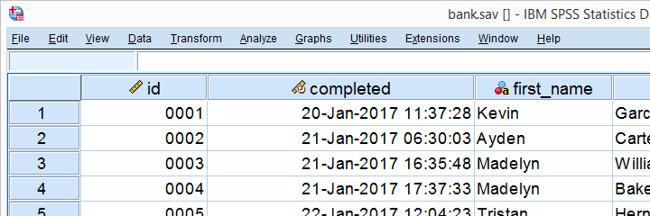

How to paste SPSS syntax?

Now let's suppose I'd like to gain some insight into the percentages of male and female respondents. I could first navigate to Analyze SPSS Menu ArrowDescriptive statistics SPSS Menu ArrowFrequencies as shown below.

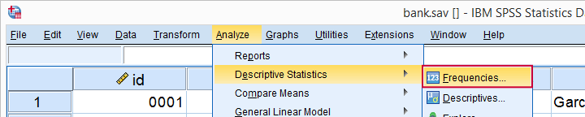

I'll now https://spss-tutorials.com/img/b1.pngmove gender into the variable box and perhaps https://spss-tutorials.com/img/b3.pngrequest a bar chart as well.

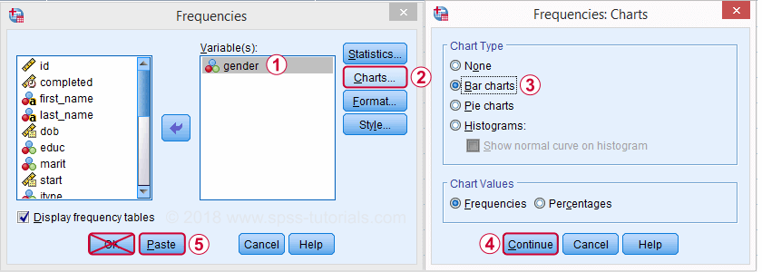

Now clicking Ok may *seem* the obvious thing to do. A much better idea, however, is to click the Paste button. Upon doing so, a new SPSS window opens which is known as the Syntax Editor. It's recognized by the orange icon https://spss-tutorials.com/img/spss-syntax-editor-icon.pngin its left top corner.

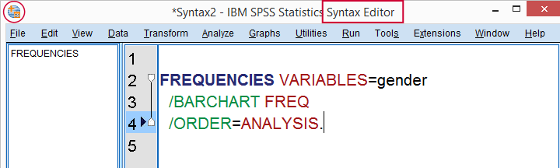

The Syntax Editor contains a FREQUENCIES command which holds the instructions we just gave SPSS in the Frequencies dialog. However, we don't see the [frequency distribution](https://www.spss-tutorials.com/frequency-distribution-what-is-it/) and [bar chart](https://www.spss-tutorials.com/spss-bar-charts-tutorial/) we asked for. This is because we still need to *run* the command we just created.

How to run SPSS syntax?

The simplest way to run syntax is to select the command(s) you'd like to run and click the “run selection” icon https://spss-tutorials.com/img/spss-run-syntax-arrow.pngin your toolbar.

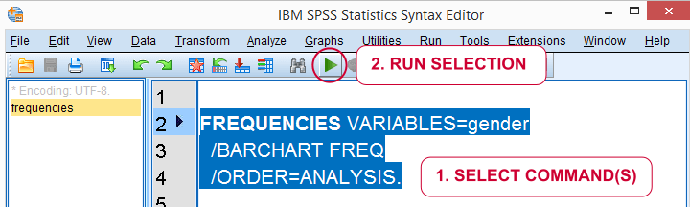

A faster way to run syntax is to use several [shortkeys](https://www.spss-tutorials.com/spss-keyboard-shortcuts/), especially

* F2 for selecting the command in which your mouse pointer is located;
* Ctrl + a for selecting *all* syntax;
* Ctrl + r for running all selected commands.

So let's now run our pasted syntax. On doing so, a new window will open, containing our frequency table and barchart. This is an [output window](https://www.spss-tutorials.com/spss-output-viewer-window/) which we'll discuss in our next tutorial.

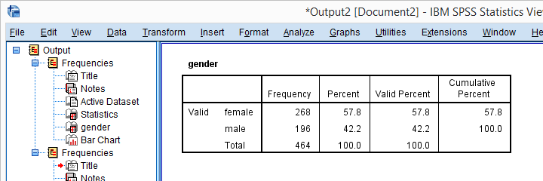

How to get SPSS syntax?

The right way to do basically anything in SPSS -editing and [analyzing data](https://www.spss-tutorials.com/spss-data-analysis/), creating tables and charts and more- is by running syntax. So how to get syntax? First off, using the Paste button from the menus adds syntax to your syntax window. If you don't have a syntax window open yet, it'll open one for you. Options for **opening a syntax window** are

* using the Paste button from the menus;
* drag and drop a syntax file into the Data Editor window (shown below);
* clicking the New Syntax https://spss-tutorials.com/img/spss-new-syntax-window-icon.pngtoolbar icon;
* Navigate to File SPSS Menu ArrowNew SPSS Menu ArrowSyntax.

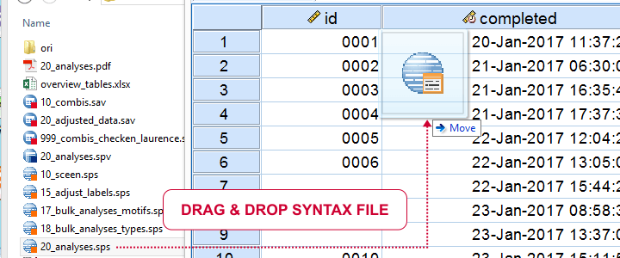

If you've a syntax window open, you still need the actual syntax. Options to **get the syntax** you need are

* use the Paste button from SPSS’ menu;
* copy-paste syntax from our tutorials, online forums and elsewhere;
* type the commands you need into the syntax window.

## Writing simpler syntax

The syntax we just pasted from the menu was:

FREQUENCIES VARIABLES=gender  
/BARCHART FREQ  
/ORDER=ANALYSIS.

Now typing all that manually is a lot of work. However, we'll get the **exact same results** if we run:

frequencies gender  
/barchart.

Just typing and running this is much **faster** and easier than clicking through all menu options. So if you want to get real good -and real fast- with SPSS, start learning short syntax. This will take some practice but it will save you tons of time and effort in the longer run.

## SPSS Syntax Files

We can now save all contents of our Syntax Editor as a syntax file by going to File SPSS Menu ArrowSave as... The resulting syntax file has the .sps (for “SPSS syntax”) file extension and is a plain text file. You can open, edit and save it with SPSS or any text editor such as [Notepad++](http://notepad-plus-plus.org/).  
When saving syntax in newer SPSS versions, something like * Encoding: UTF-8.may be added. Just leave and **ignore this**, it's not meant for you but, rather, some kind of “note to self” from SPSS.

# Descriptives Analysis: Central Tendency

Descriptive statistics are informative statistics that describe datasets. Measures of central tendency are a type of descriptive statistics. Measures of central tendency include the **Mean** (average), **Median** (middlemost data point), and **Mode** (most common data point) of a datset.

This example will get measures of central tendency for the respondents' ages, the 'age' variable.

To get measures of central tendency, click on 'Analyze' in the toolbar at the top of the Data Editor window. Then, click 'Descriptive Statistics' in the dropdown menu and 'Frequencies' in the side menu. (Please note: this tutorial recommends using the 'Frequencies...' function rather than the 'Descriptives...' function to get measures of central tendency because the 'Frequencies...' function offers options for more measures of central tendency than does the 'Descriptives...' function.)

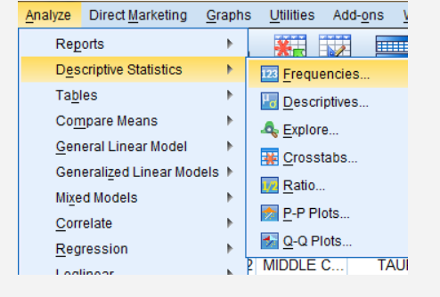

In the Frequencies dialog box that pops up, double click on the variable of interest (Age of Respondents) in the variable list to add it to the 'Variable(s):' field. If you would like your output to display frequency tables as well, select the 'Display frequency tables' box. Then, click 'Statistics...'

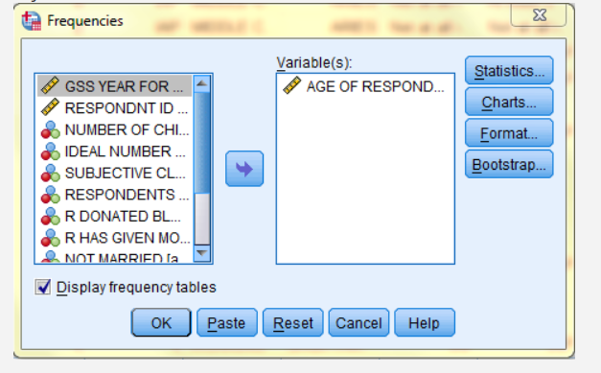

In the Frequencies: Statistics dialog box that pops up, check off mean, median, and mode, and any other desired statistics. Then, click 'Continue.' Back in the Frequencies dialog box, click OK, and the measures of central tendency will be displayed in a table in the SPSS Viewer output window. 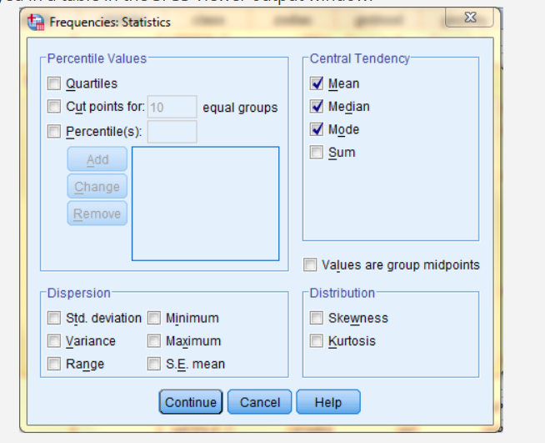

In the SPSS Viewer window, the output is displayed. The descriptive statistics, the measures of central tendency, are displayed in the Statistics table. (This output also includes a frequency table, Age of Respondent. In this table, the frequency of each age is displayed. For example, 12 respondents, .6% of all respondents, are age 18.)

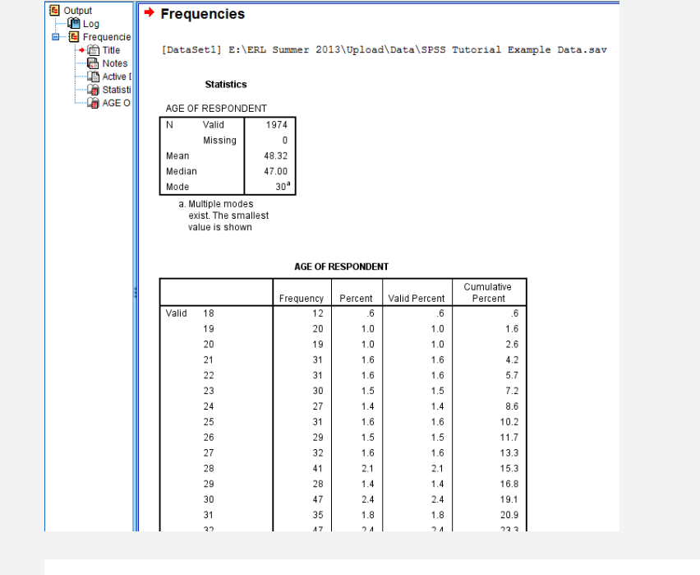

# Descriptives Analysis: Dispersion and Variability

Descriptive statistics are informative statistics that describe datasets. Measures of dispersion and variability are a type of descriptive statistics. Measures of dipersion and variability include the **Minimum**, **Maximum**, **Range**(the difference between the minimum and maximum), **Variance** (the average difference between each data value and the mean, squared), **Standard Deviatio**n (the square root of the variance), and **Standard Error of the Mean** (the standard deviation of the sample mean's estimated true population mean) of a datset. The greater the values of these statistics, the more varied and dispersed the distribution.

This example will get measures of variability for the respondents' ages, the 'age' variable.

To get measures of dispersion and variability, click on 'Analyze' in the toolbar at the top of the Data Editor window. Then, click 'Descriptive Statistics' in the dropdown menu and 'Descriptives...' in the side menu.

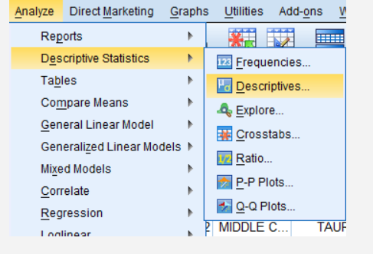

In the Descriptives dialog box that pops up, double click on the variable of interest (Age of Respondents) in the variable list to add it to the 'Variable(s):' field. Then, click 'Options...'

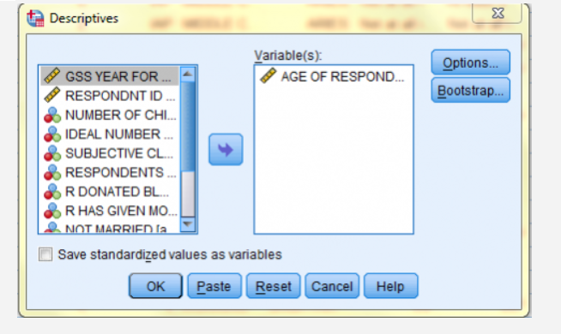

In the Descriptives: Options dialog box that pops up, check off Standard Deviation, Variance, Range, Minimum, Maximum, and Standard Error of the Mean, and any other desired statistics. Then, click 'Continue.' Back in the Descriptives dialog box, click OK, and the measures of dispersion and variability will be displayed in a table in the SPSS Viewer output window.

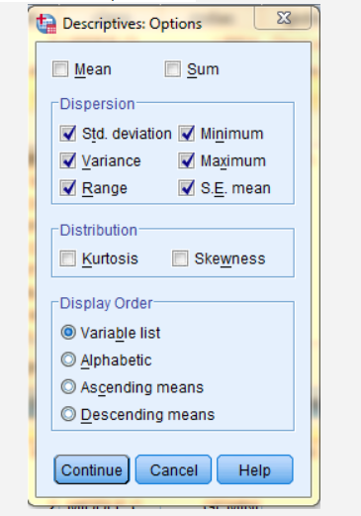

In the SPSS Viewer window, the output is displayed. The descriptive statistics, the measures of dispersion and variability, are displayed in the Descriptive Statistics table.

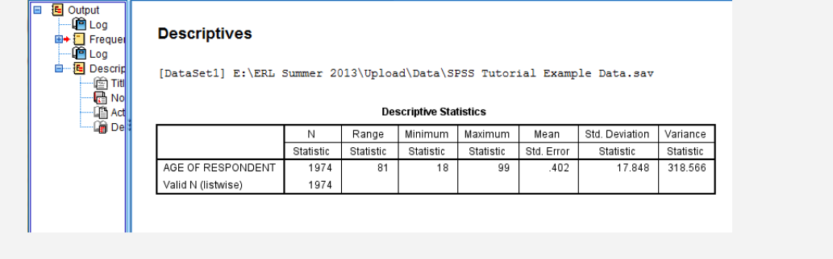

# Descriptives Analysis: Distribution and Normality

Descriptive statistics are informative statistics that describe datasets. Measures of distribution and normality are a type of descriptive statistics. Measures of distribution and normality include **Skewness** and **Kurtosis.**

Interpreting skewness and kurtosis:

**Skewness**: The closer the skewness value to zero, the more symmetrical the distribution. Positive large values indicate a positively skewed distribution and negative large values indicate a negatively skewed distribution

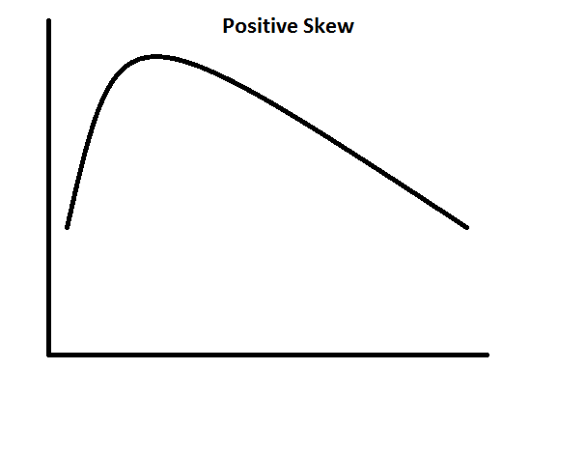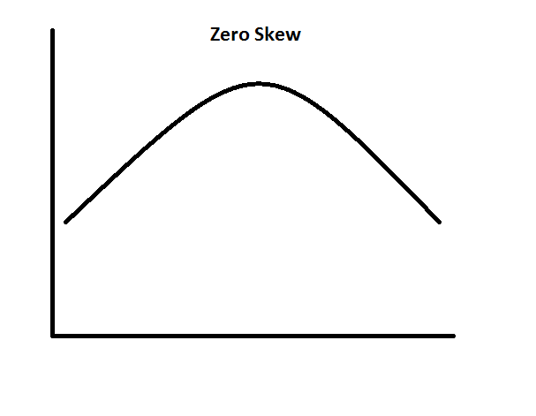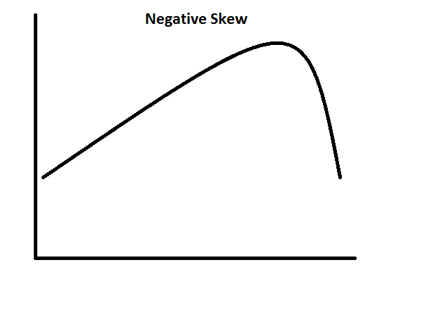

**Kurtosis**: The closer the kurtosis value to zero, the more normal the distribution of scores. A distribution is more leptokurtic (peaked) when the kurtosis value is a large positive value, and a distribution is more platykurtic (flat) when the kurtosis value is a large negative value.

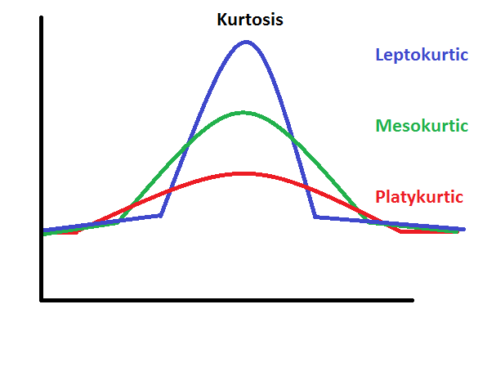

This example will get measures of distribution and normality for the respondents' ages, the 'age' variable.

To get measures of distribution and normality, click on 'Analyze' in the toolbar at the top of the Data Editor window. Then, click 'Descriptive Statistics' in the dropdown menu and 'Descriptives...' in the side menu.

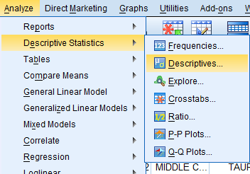

In the Descriptives dialog box that pops up, double click on the variable of interest (Age of Respondents) in the variable list to add it to the 'Variable(s):' field. Then, click 'Options...'

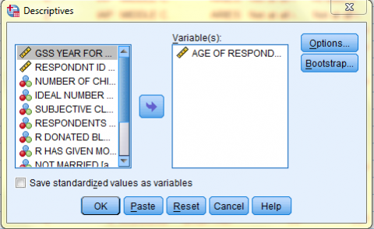

In the Descriptives: Options dialog box that pops up, check off Kurtosis and Skewness and any other desired statistics. Then, click 'Continue.' Back in the Descriptives dialog box, click OK, and the measures of distribution and normality will be displayed in a table in the SPSS Viewer output window.

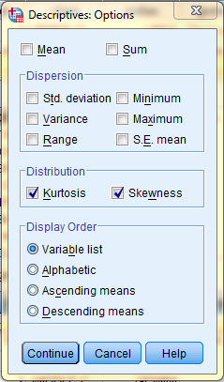

In the SPSS Viewer window, the output is displayed. The descriptive statistics, the measures of distribution and normality, are displayed in the Descriptive Statistics table.

